1. Write a SQL query to map all the Employee Names with the remaining names.

CREATE TABLE [Emp_table]

(

Emp_ID INT

,Emp_Name VARCHAR(10)

,Age INT

)

GO

INSERT INTO [Emp_table] VALUES

(1,'A',25),

(2,'B',35),

(3,'C',45),

(4,'D',45)

GO

**I/P:**

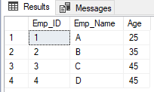

**Expected O/P:**

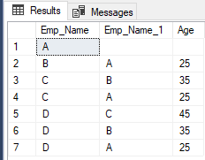

select

A.emp_name,B.emp_1,B.age

from

(select * from emp_table ) A

left join

(select D.emp_name emp_name,C.emp_name as emp_1, C.age age from [Emp_table] C

cross join [Emp_table] D

where C.emp_name<D.emp_name

) B

on A.emp_name = B.emp_name

order by

A.emp_name,

B.age desc

2. The view consists of two columns (score1 and score2 ). Can you identify the reciprocal pair of scores?

create view V_1 (Score1,Score2)

as

select 20,20

union all

select 50,25

union all

select 20, 20

union all

select 60,30

union all

select 70,90

union all

select 80,130

union all

select 90,70

union all

select 100,50

UNION ALL

select 110,55

union all

select 120,60

UNION ALL

select 130,80

union all

select 140,70

;

**I/P:**

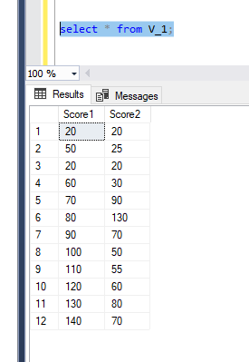

**Expected O/P:**

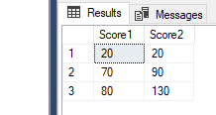

select distinct *

from V_1

where score1-score2<=0

3. Refer the below input data and the expected output to generate the report on range basis on the common combination of dispatch_flag and keep_flag.

CREATE TABLE tbl_flags

(

ID INT

,Creation_Date DATE

,dispatch_flag BIT

,keep_flag BIT

);

INSERT INTO tbl_flags

VALUES

(1,'20160808',0,0)

,(2,'20161001',0,0)

,(3,'20161126',1,0)

,(4,'20161226',1,0)

,(5,'20170108',1,0)

,(6,'20170310',1,1)

,(7,'20170620',1,1)

,(8,'20170815',0,1);

**I/P:**

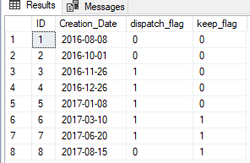

select min(id) as start_id,max(id) as end_id ,dispatch_flag,keep_flag

from tbl_flags

group by dispatch_flag,keep_flag

order by start_id

**Expected O/P:**

